Assignment 2

Smitesh Patil, id = 22223696

20 September, 2022

## Starting with R-Markdown

In the following R-Markdown document some data are created followed by calculation of some summary statistics and display of graphical summaries. All the results are embedded for you in the report when you knit the document into a report.

The following R chunk creates a dataset in a vector and stores it in R’s memory using the name x. You will have been given some directions in how to adapt this dataset on Blackboard.

x = c(10, 23, 14, 12, 34, 26, 28)  
x <- append(x, 24)

The mean of this data is

mean(x)

## [1] 21.375

The summary statistics (minimum, maximum, $Q_{1}$, median, mean and $Q_{3}$) obtained from the summary() function are:

summary(x)

## Min. 1st Qu. Median Mean 3rd Qu. Max.   
## 10.00 13.50 23.50 21.38 26.50 34.00

The five number summary which uses Tukey’s method to estimate the lower and upper quartiles ( $Q_{1}$ and $Q_{3}$) is given below. Notice the small differences in these quartiles.

fivenum(x)

## [1] 10.0 13.0 23.5 27.0 34.0

The boxplot of the data below also uses Tukey’s method. I would describe the shape of the distribution using the boxplot as right skewed.

boxplot(x, horizontal = TRUE)

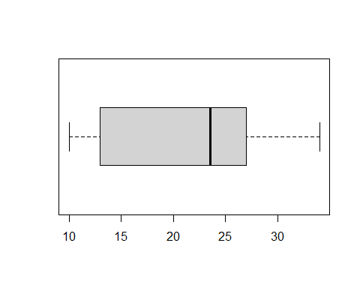

A histogram is given below. I would describe the shape of the distribution using the histogram as right skewed. Although number of data points in the dataset are less to make any conclusion on the shape of histogram.

hist(x)

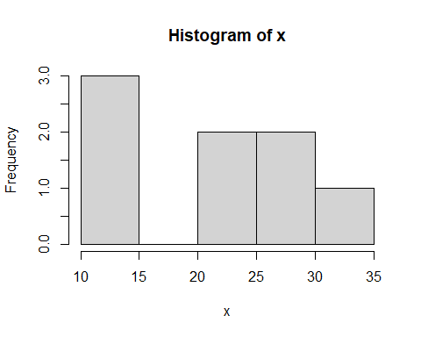

Use the help system in R to learn how to use the breaks argument in the hist function to include around 10 breakpoints. To use the help system type help(hist)

hist(x, breaks=10)

